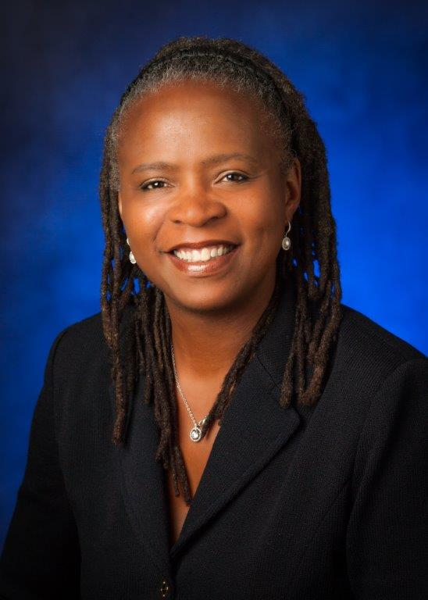  
Lisa Marie Harris has served as Director of Finance/Treasurer for the San Diego County Water Authority since May 2014. Ms. Harris has over 27 years of financial experience in both the public and private sector. Ms. Harris is responsible for overseeing the Water Authority’s $2.3 billion debt portfolio, over $500 million investment portfolio and responsible for the development of the bi-annual $1.5 billion operating budget and the setting of annual Rates and Charges. Prior to joining the Water Authority, Ms. Harris served as Chief Deputy Treasurer for the County of San Diego Treasurer-Tax Collector’s Office;Executive Director of CA Debt and Investment Advisory Commission (CDIAC); Assistant Deputy Airport Director for the City and County of San Francisco - San Francisco International Airport; and most recently Senior Vice President for Siebert Brandford Shank LLC. Ms. Harris holds a Bachelor's degree in Economics from University at California, Berkeley and a Master’s degree in Public Policy from the University of Michigan. Ms. Harris is a past executive board member and currently serving on the Debt and Nominations Committees for Government Finance Officers Association.  Ms. Harris also is a past executive board member for Women in Public Finance (WPF) and founding member and Vice President for the San Diego Chapter of WPF.

She is a proud parent of two college age children.  Camille is in her third year at UC Berkeley studying Computer Science and recently elected as President of the Black Engineering Science Association and George is a first year student at UC Santa Barbara studying Political Science and member of their Division One Track and Field Team.